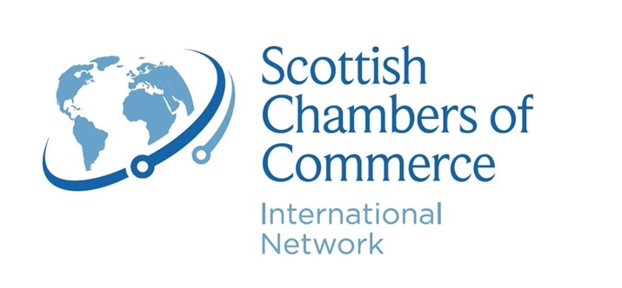
Application Form for London Business Visit 2023
15th May – 18th May 2023
Scottish Chambers of Commerce (SCC) is pleased to invite applications for delegates from Scottish businesses for SCC’s annual London Business Visit.

The annual Scottish Chambers of Commerce London Business Visit is established as Scottish business’s premium political and commercial networking and influencing forum in the capital. These visits offer companies from Scotland unrivalled access to top Westminster politicians and city business leaders.

The 2023 Business Visit will take place from 15th – 18th May 2023 and will offer delegates the exclusive chance to meet global and national business leaders, Ambassadors, international business owners and participate in roundtables as well as attending the British Chambers of Commerce Global Conference.

This year’s visit will help you identify new markets and supply chain opportunities, provide international advice to support market entry and export initiatives and access our global network.

Powers reserved to the UK Government in these areas are vitally important to Scotland’s businesses and the wider Scottish economy and SCC will cover a range of business issues including infrastructure, investment, and international trade during this visit.

Cost – £500 + VAT
Please note that numbers are restricted for the London Business Visit.
Delegates will be required to pay their own travel and accommodation costs.
SCC may be able to offer discounted rates at some London hotels.
BCC Global Conference ticket of £120 + VAT is included in the price.​

Name:
Company:
Job Title:
eMail:
Mobile No.:
Company Address:
City:
Post Code:
Website:
Company LinkedIn profile:
Do you currently export? | Yes ☐ No ☐
If ‘yes’, to which markets?
If ‘no’, what are the barriers you’ve faced?
Annual turnover at last year end (£):
Turnover from international sales at last year end (£):
No of employees (FTE):
Business sector:
Business description including your product / services:
Please describe your product/service:
Who are your competitors?
What is/are main objective(s) for joining this business visit?
Any questions?
You must be willing to participate in a case study: | Yes ☐
Would you like to receive a copy of our daily enewsletter straight to your inbox each morning: | Yes ☐ No ☐

Please complete the below form and return to Ros Wardley-Smith at: Ros.Wardley-Smith@scottishchambers.org.uk

